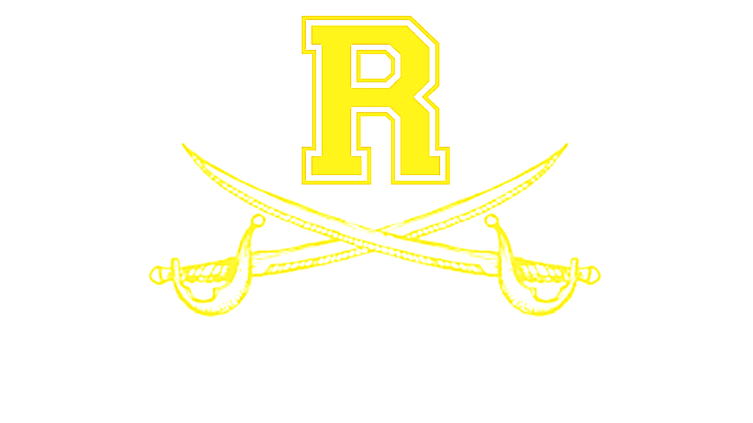

Richmond Varsity Academy Basketball

|  |  |  |  |  |  |
| --- | --- | --- | --- | --- | --- |
| **Date** | **Day** | **Time** | **Opponent** | **Boys/Girls** | **Location** |
| **Nov. 8** | **Fri.** | **6, 7:30pm** | **Josey** | **Boys/Girls** | **Richmond** |
| **Nov. 12** | **Tue.** | **6, 7:30pm** | **Laney** | **Boys/Girls** | **Richmond** |
| **Nov. 15** | **Fri.** | **4:30/7:30pm** | **Rickey Moore Classic**  **Girls vs Aug. Christian @ 4:30**  **Boys vs Aug. Christian @ 7:30** | **Boys/Girls** | **Curtis Baptist** |
| **Nov. 16** | **Sat.** | **4:30/9:00** | **Rickey Moore Classic**  **Girls vs 1st Baptist @ 4:30**  **Boys vs Midland Stem @ 9:00** | **Boys/Girls** | **Westside (2nd Gym)** |
| **Nov. 19** | **Tue** | **6, 7:30pm** | **Laney** | **Boys/Girls** | **Laney** |
| **Nov. 29** | **Sat.** | **TBA** | **100 Blk. Men Thanksgiving Classic (TBA)** | **Boys** | **TBA** |
| **Dec. 3** | **Tue.** | **6, 7:30pm** | **Harlem\*** | **Boys/Girls** | **Richmond** |
| **Dec. 6** | **Fri.** | **6, 7:30pm** | **Thomson** | **Boys/Girls** | **Thomson** |
| **Dec. 10** | **Tue.** | **6, 7:30pm** | **Cross Creek\*** | **Boys/Girls** | **Richmond** |
| **Dec. 13** | **Fri.** | **6, 7:30pm** | **Hephzibah\*** | **Boys/Girls** | **Hephzibah** |
| **Dec.17** | **Tue.** | **6, 7:30pm** | **Baldwin\*** | **Boys/Girls** | **Baldwin** |
| **Dec. 20** | **Fri.** | **6, 7:30pm** | **Westside\*** | **Boys/Girls** | **Westside** |
| **Dec. 26** | **Thur.** | **TBA** | **Girls: North Augusta**  **Boys: Washington Co.** | **Boys/Girls** | **Laney** |
| **Dec. 27** | **Fri.** | **TBA** | **Girls: South Aiken**  **Boys: Josey** | **Boys/Girls** | **Laney** |
| **Dec. 28** | **Sat.** | **TBA** | **Girls: TBA**  **Boys: Glenn Hills** | **Boys/Girls** | **Laney** |
| **Jan. 3** | **Fri.** | **6, 7:30pm** | **Howard\*** | **Boys/Girls** | **Richmond** |
| **Jan. 4** | **Sat.** | **6, 7:30pm** | **Aquinas\*** | **Boys/Girls** | **Aquinas** |
| **Jan.7** | **Tue.** | **6, 7:30pm** | **West Laurens\*** | **Boys/Girls** | **Richmond** |
| **Jan. 10** | **Fri.** | **4, 5:30, 7,**  **8:30pm** | **Harlem\*** | **Boys/Girls JV&V** | **Harlem** |
| **Jan. 17** | **Fri.** | **6, 7:30pm** | **Cross Creek\*** | **Boys/Girls** | **Cross Creek** |
| **Jan. 21** | **Tue.** | **6, 7:30pm** | **Hephzibah\*** | **Boys/Girls** | **Richmond** |
| **Jan.24** | **Fri.** | **6, 7:30pm** | **Baldwin\*** | **Boys/Girls** | **Richmond** |
| **Jan. 28** | **Tue.** | **6, 7:30pm** | **Westside\*** | **Boys/Girls** | **Richmond** |
| **Jan. 31** | **Fri.** | **6, 7:30pm** | **Howard\*** | **Boys/Girls** | **Howard** |
| **Feb. 4** | **Tue.** | **6, 7:30pm** | **Aquinas\*** | **Boys/Girls** | **Richmond** |
| **Feb. 7** | **Fri.** | **6, 7:30pm** | **West Laurens\*** | **Boy/Girls** | **West Laurens** |

**Boys Coaching Staff Girls Coaching Staff**

**Steve Nobles – Head Coach** **Warren** **Washington- Head Varsity Coach**

**Shaun Bradley – Assistant Coach Jamia Bradley- Assistant Coach**

**Chris Jones – Assistant Coach Adam Mullis- Head JV/Assistant Coach**

**Jerry Arnett – Assistant Coach**